Numerical Laboratory Activity 1

Submitted to: Engr. Harold M. Ticzon

Submitted by:
Andrei Luis M. Monfero
Jun Michael C. Salvador
Gabriel Joseph M. Sia

BSCPE 2-B

Exercise 4
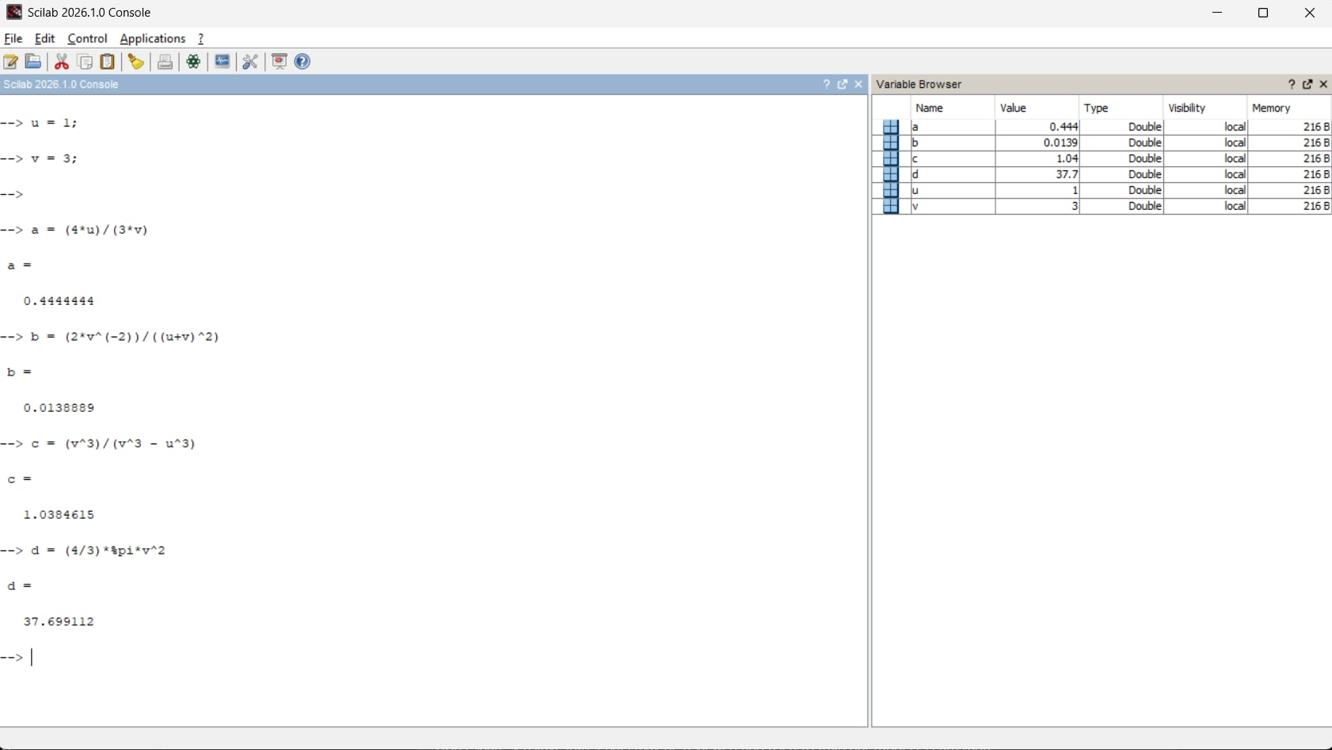

Exercise 5
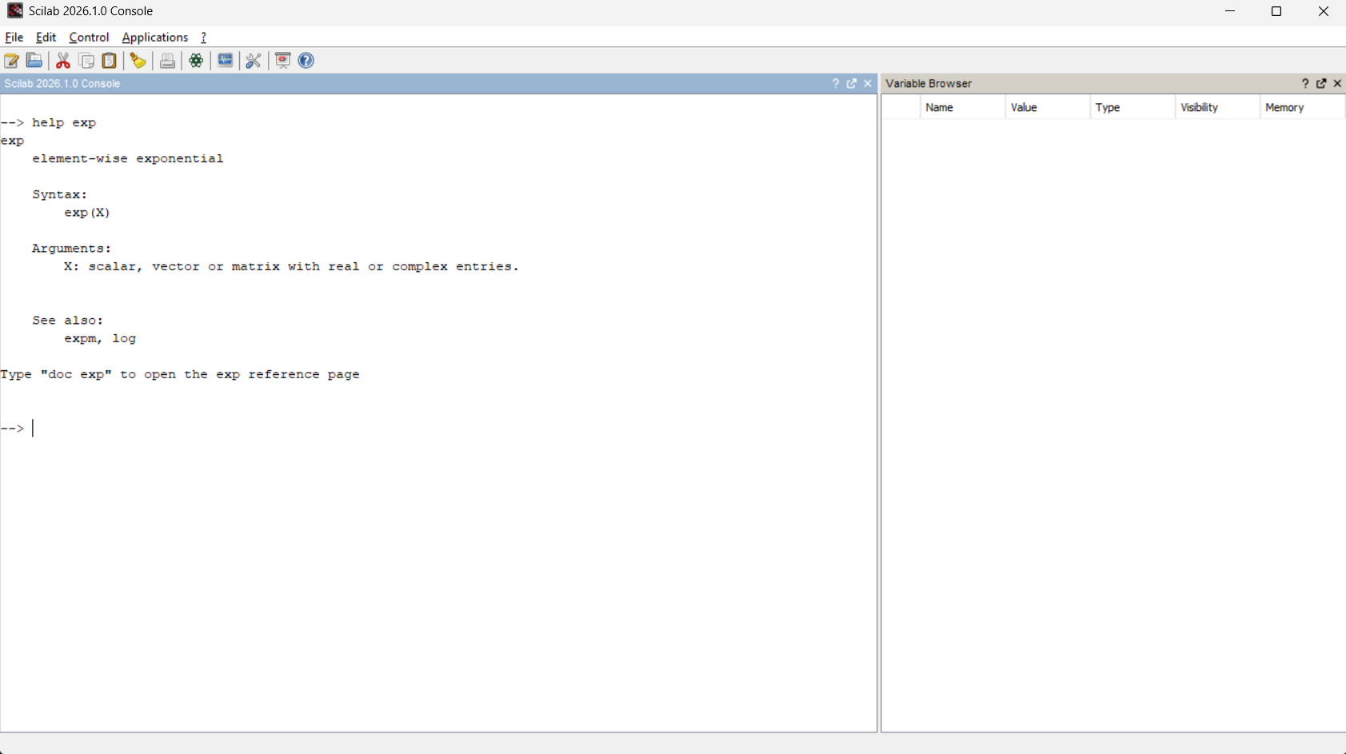
A.

B.
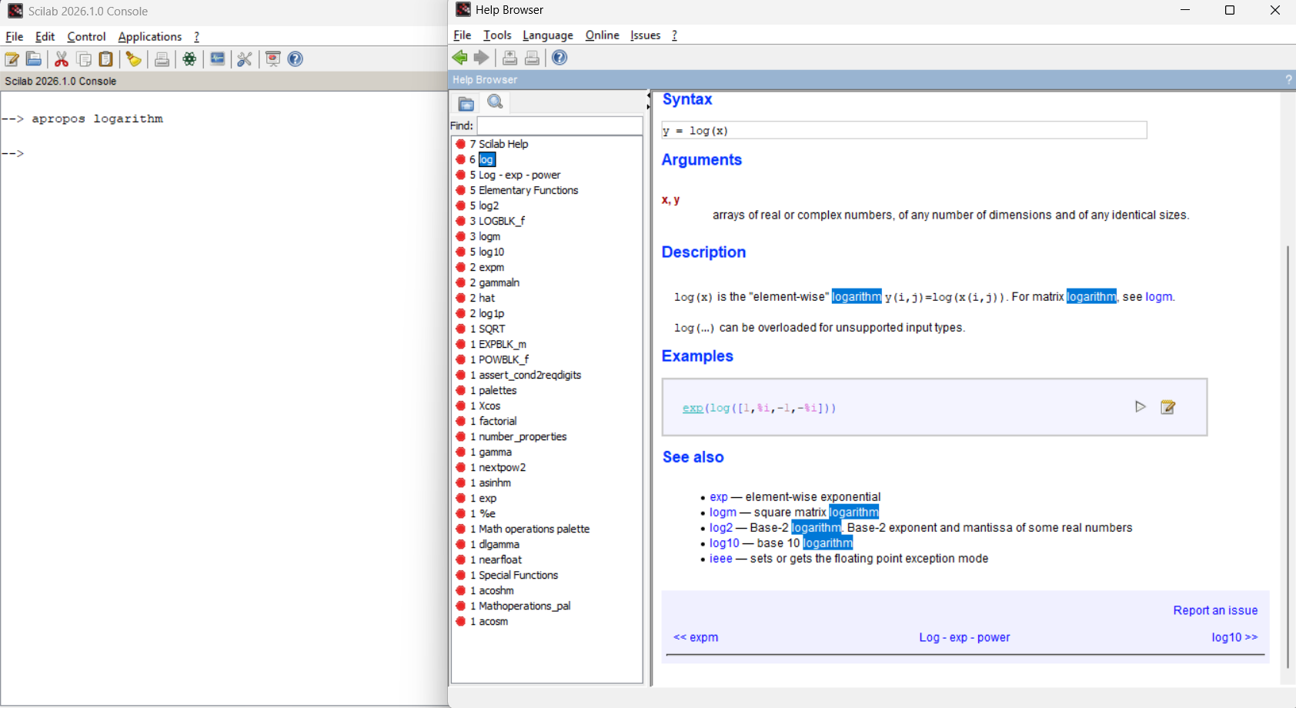

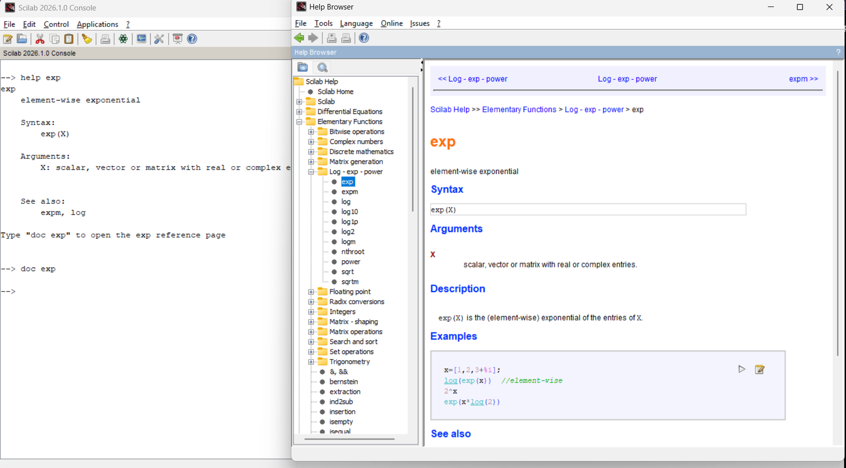
Exercise 6

